### Report on CO2 Concentration Prediction Using ARIMA

#### ****1. Introduction**** 1.

The aim of this project is to analyze CO2 sensor data, determine the stationarity of the data, and develop an ARIMA-based time-series forecasting model. This report presents the results of the analysis, discusses the model's performance, and reflects on the challenges faced during the process.

#### ****2. Dataset Analysis****

The dataset consists of sensor readings for temperature, humidity, light intensity, and CO2 concentration. A summary of the dataset is as follows:

* **Observation Period:** Time-series data spanning several days.
* **Key Metrics (CO2):**
  + Mean: 753.22
  + Standard Deviation: 297.09
  + Range: 484.67 to 2076.50

##### Correlation Analysis

The correlation matrix reveals:

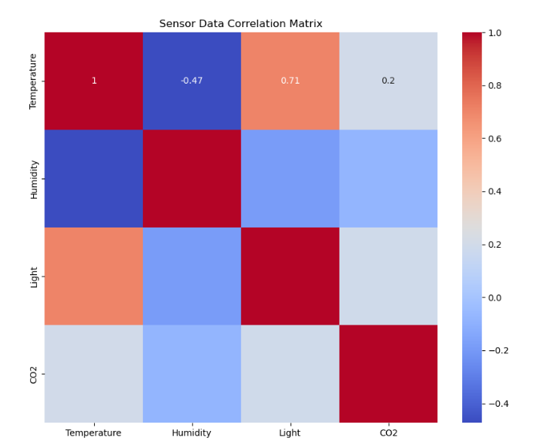

Correlation Analysis:

Temperature Humidity Light CO2

Temperature 1.000000 -0.472921 0.705538 0.199646

Humidity -0.472921 1.000000 -0.187477 -0.079224

Light 0.705538 -0.187477 1.000000 0.190213

CO2 0.199646 -0.079224 0.190213 1.000000

The correlation analysis reveals several key relationships among the variables in the dataset. Temperature shows a weak positive correlation (0.20) with CO2, indicating that as temperature increases, CO2 levels tend to rise slightly, although the relationship is not particularly strong. Similarly, Light also demonstrates a weak positive correlation (0.19) with CO2, suggesting that higher light intensity might be associated with slightly elevated CO2 levels. On the other hand, Humidity exhibits a very weak negative correlation (-0.08) with CO2, implying that changes in humidity have minimal influence on CO2 concentrations. These findings suggest that while Temperature and Light might provide some predictive power for CO2 levels, their individual contributions are limited. Additionally, the strong positive correlation (0.71) between Temperature and Light highlights a significant interdependence, likely driven by environmental factors such as heat generated by light sources. The moderate negative correlation (-0.47) between Temperature and Humidity further reflects their inverse relationship, consistent with physical phenomena where rising temperatures often lead to lower relative humidity. Overall, while these variables offer some insights into CO2 behavior, their weak individual correlations with CO2 suggest that predictive models may benefit from incorporating additional features or exploring more complex relationships.

#### ****3. Data Stationarity****

Using the Augmented Dickey-Fuller (ADF) test, we tested the stationarity of the CO2 data. The ADF statistic confirmed that the data is non-stationary in its raw form. Differencing (d=1) was applied to achieve stationarity.

#### ****4. ARIMA Model Selection****

The auto_arima function was used to determine the best-fit ARIMA parameters:

* Best Model: **ARIMA(2,1,2)** with the following:
  + **p** (autoregressive order): 2
  + **d** (degree of differencing): 1
  + **q** (moving average order): 2
* AIC Score: **59231.77**
* Total model fit time: ~38 seconds.

#### ****5. Forecasting and Results****

The CO2 data was split into 70% training and 30% test sets. Predictions were made using a stepwise approach, updating the model every fixed number of steps.

##### Performance Metrics:

**Refit Every 100 Steps (i % 100)**:

MAE:75.29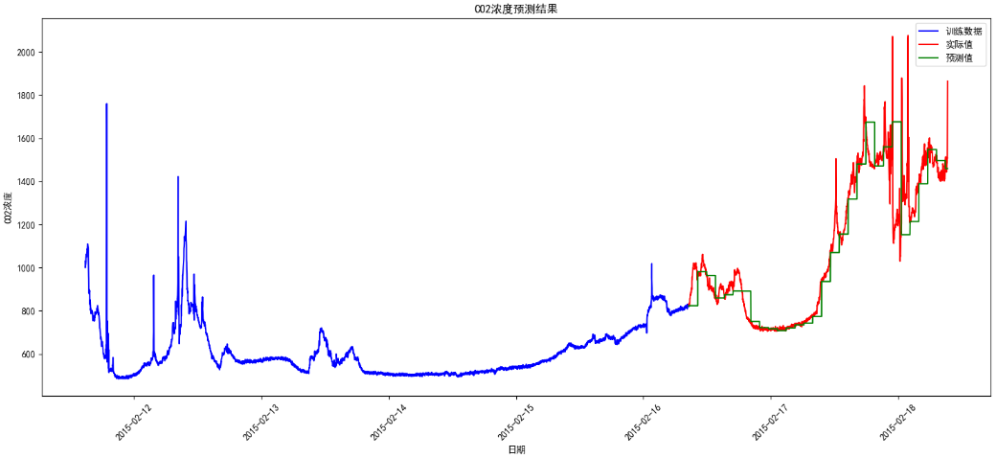

**Refit Every 20 Steps (i % 20)**:

* + MAE: 31.73
  + RMSE: 73.28

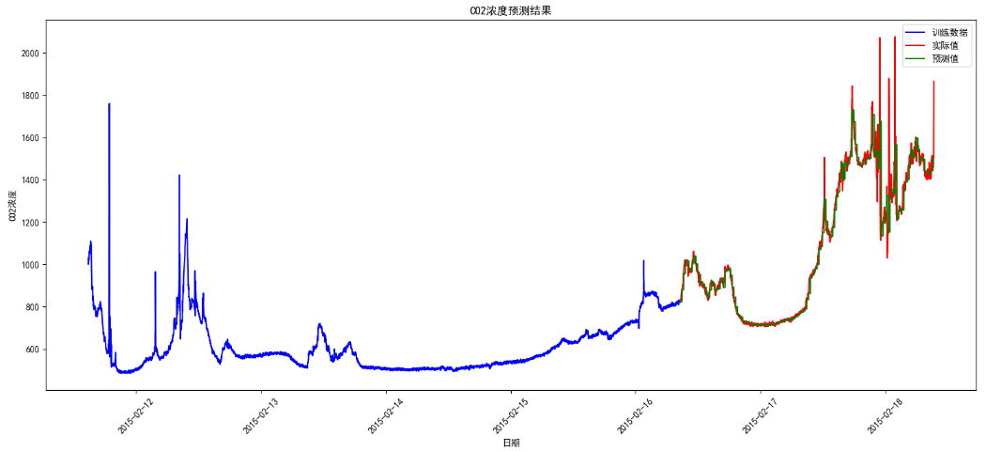

**Refit Every 5 Steps (i % 5)**:

* + MAE: 16.44
  + RMSE: 40.37

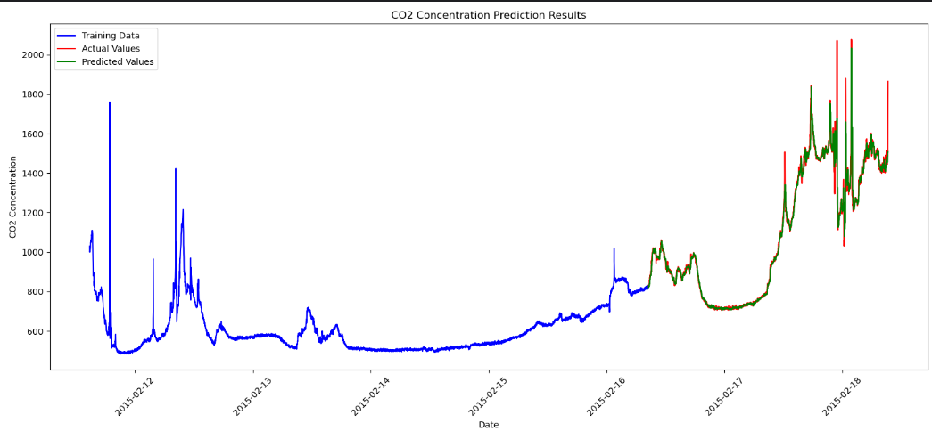

##### Observations:

* Frequent refitting (i.e., every 5 steps) resulted in the lowest prediction error (MAE: 16.44, RMSE: 40.37).
* While computationally expensive, frequent updates significantly improve accuracy by capturing short-term variations in the data.
* Predictions struggle with outliers, highlighting the need for better anomaly handling.

#### ****6. Challenges and Reflections****

**Handling Non-Stationarity**:

* + Achieving stationarity was straightforward using differencing (d=1). However, this transformation may have led to the loss of some long-term trends.

**Outlier Sensitivity**:

* + Predictions were less accurate for outliers. In real-world applications like industrial or financial forecasting, such anomalies are common and need robust handling mechanisms.

**Trade-Off Between Accuracy and Computation**:

* + Frequent refitting (e.g., every 5 steps) improved accuracy but increased computation time. Optimizing the refit frequency based on prediction errors could balance this trade-off.

**Model Generalizability**:

* + The ARIMA model performed well for linear and stationary data but may not generalize to non-linear relationships. Hybrid models (e.g., ARIMA + LSTM) can be explored.

#### ****7. Recommendations****

**Incorporate Anomaly Detection**

* + Use statistical or machine-learning methods to identify and preprocess outliers.

**Hybrid Modeling**:

* + Combine ARIMA with neural networks to handle both linear and non-linear patterns in the data.

**Dynamic Refit Intervals**:

* + Implement dynamic refitting, where the model updates only when prediction errors exceed a defined threshold.

**Feature Engineering**:

* + Integrate additional external variables, such as weather or industrial activity, to improve the model's explanatory power.

The ARIMA(2,1,2) model effectively forecasted CO2 concentration, achieving a mean absolute error of 16.44 with frequent refitting. While the model demonstrates the potential of ARIMA for sensor data analysis, challenges like outlier sensitivity and computational efficiency must be addressed for industrial-scale applications.

### **APPIDEX: CO2 Concentration Forecasting Experiment (5 Steps)**

#### **Dataset Basic Information**

Temperature Humidity Light CO2

date

2015-02-11 14:48:00 21.7600 31.133333 437.333333 1029.666667

2015-02-11 14:49:00 21.7900 31.000000 437.333333 1000.000000

2015-02-11 14:50:00 21.7675 31.122500 434.000000 1003.750000

2015-02-11 14:51:00 21.7675 31.122500 439.000000 1009.500000

2015-02-11 14:51:00 21.7900 31.133333 437.333333 1005.666667

**Descriptive Statistics of the Dataset:**

Temperature Humidity Light CO2

count 9752.000000 9752.000000 9752.000000 9752.000000

mean 21.001768 29.891910 123.067930 753.224832

std 1.020693 3.952844 208.221275 297.096114

min 19.500000 21.865000 0.000000 484.666667

25% 20.290000 26.642083 0.000000 542.312500

50% 20.790000 30.200000 0.000000 639.000000

75% 21.533333 32.700000 208.250000 831.125000

max 24.390000 39.500000 1581.000000 2076.500000

**Searching for the best ARIMA parameters...**

Performing stepwise search to minimize aic

ARIMA(0,1,0)(0,0,0)[0] intercept : AIC=60029.820, Time=0.09 sec

ARIMA(1,1,0)(0,0,0)[0] intercept : AIC=59997.355, Time=0.20 sec

ARIMA(0,1,1)(0,0,0)[0] intercept : AIC=59979.849, Time=0.62 sec

ARIMA(0,1,0)(0,0,0)[0] : AIC=60027.837, Time=0.04 sec

ARIMA(1,1,1)(0,0,0)[0] intercept : AIC=59656.767, Time=1.10 sec

ARIMA(2,1,1)(0,0,0)[0] intercept : AIC=59244.234, Time=1.56 sec

ARIMA(2,1,0)(0,0,0)[0] intercept : AIC=59748.541, Time=0.28 sec

ARIMA(3,1,1)(0,0,0)[0] intercept : AIC=59234.899, Time=2.29 sec

ARIMA(3,1,0)(0,0,0)[0] intercept : AIC=59531.164, Time=0.34 sec

ARIMA(4,1,1)(0,0,0)[0] intercept : AIC=59235.967, Time=3.16 sec

ARIMA(3,1,2)(0,0,0)[0] intercept : AIC=59234.998, Time=5.93 sec

ARIMA(2,1,2)(0,0,0)[0] intercept : AIC=59233.687, Time=2.47 sec

ARIMA(1,1,2)(0,0,0)[0] intercept : AIC=59312.969, Time=2.03 sec

ARIMA(2,1,3)(0,0,0)[0] intercept : AIC=59235.078, Time=2.29 sec

ARIMA(1,1,3)(0,0,0)[0] intercept : AIC=59262.631, Time=1.99 sec

ARIMA(3,1,3)(0,0,0)[0] intercept : AIC=59237.204, Time=2.38 sec

ARIMA(2,1,2)(0,0,0)[0] : AIC=59231.767, Time=0.94 sec

ARIMA(1,1,2)(0,0,0)[0] : AIC=59311.070, Time=0.83 sec

ARIMA(2,1,1)(0,0,0)[0] : AIC=59242.323, Time=0.72 sec

ARIMA(3,1,2)(0,0,0)[0] : AIC=59246.320, Time=0.99 sec

ARIMA(2,1,3)(0,0,0)[0] : AIC=59233.157, Time=1.21 sec

ARIMA(1,1,1)(0,0,0)[0] : AIC=59654.883, Time=0.45 sec

ARIMA(1,1,3)(0,0,0)[0] : AIC=59260.736, Time=0.56 sec

ARIMA(3,1,1)(0,0,0)[0] : AIC=59232.982, Time=0.91 sec

ARIMA(3,1,3)(0,0,0)[0] : AIC=59235.282, Time=1.09 sec

Best model: ARIMA(2,1,2)(0,0,0)[0]

Total fit time: 34.481 seconds

**Best model parameters: (2, 1, 2)**

**Predicted data:**

